Nepal College of information Technology
Imadol lalitpur
Unit Test Fall Semester 2006/2007

Program: BE-ELX/IT Semester: I
Time: 2hrs Year: I

FM 65 PM 32

Engineering Math-I
Attempt all the questions

1. a) Define continuity of a function. Check continuity and differentiability of the function f(x) = |x| at x =0. 8
b) State and prove Rolle's theorem. 7
2. Integrate (any three) 3*5
a) 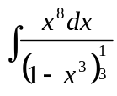 b) 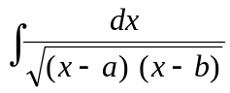
c) 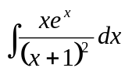 d) 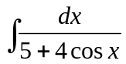 e) 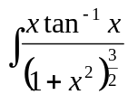
3. a) Evaluate 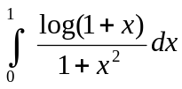 8
b) Evaluate 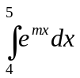 by summation method. 7
4. a) Find the area bounded by the curve x + y =2, on the left by y = x² and below by x-axis. 8
b) Find the area bounded between the parabola x² = 4y and the curve y = |x| 7
5. Solve (any two) 2.5*2
i) 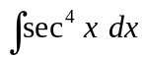
ii) 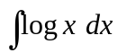
iii) Find domain and range of the function f(x) = 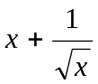

Nepal College of information Technology
Imadol lalitpur
Unit Test Fall Semester 2006/2007

Program: BE-ELX/IT Semester: I
Time: 2hrs Year: I

FM 65 PM 32

Engineering Math-I
Attempt all the questions

1. a) Define continuity of a function. Check continuity and differentiability of the function f(x) = |x| at x =0. 8
b) State and prove Rolle's theorem. 7
2. Integrate (any three) 3*5
a) b)
c) d) e)
3. a) Evaluate 8
b) Evaluate by summation method. 7
4. a) Find the area bounded by the curve x + y =2, on the left by y = x² and below by x-axis. 8
b) Find the area bounded between the parabola x² = 4y and the curve y = |x| 7
5. Solve (any two) 2.5*2
i)
ii)
iii) Find domain and range of the function f(x) =

